Outlook Email Basics and Beyond
Professional Development
September 24, 2014

Professional Teaching Standard 5e
Participating in a Professional Community
The teacher maintains rapport with colleagues—consistently communicates professionally with staff.

Add an e-mail signature to messages
Create a signature
- Open a new message. On the Message tab, in the Include group, click Signature, and then click Signatures.
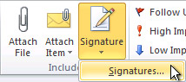
- On the E-mail Signature tab, click New.

Add a signature
- In a new message, on the Message tab, in the Include group, click Signature, and then click the signature that you want.
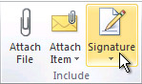
Change Stationery
- While in Signature mode, click Personal Stationery.
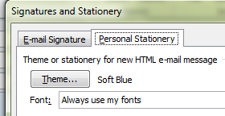

Add an attachment to an e-mail message
- Create a message, or for an existing message, click Reply, Reply All, or Forward.
- In the message window, on the Message tab, in the Include group, click Attach File.
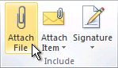

Open or save an e-mail message attachment
Open an attachment
- Double-click the attachment.
Save an attachment
- Click the attachment in the Reading Pane or the open message.
- On the Attachments tab, in the Actions group, click Save As. You can also right-click the attachment, and then click Save As.

Standard Outlook 2010 View
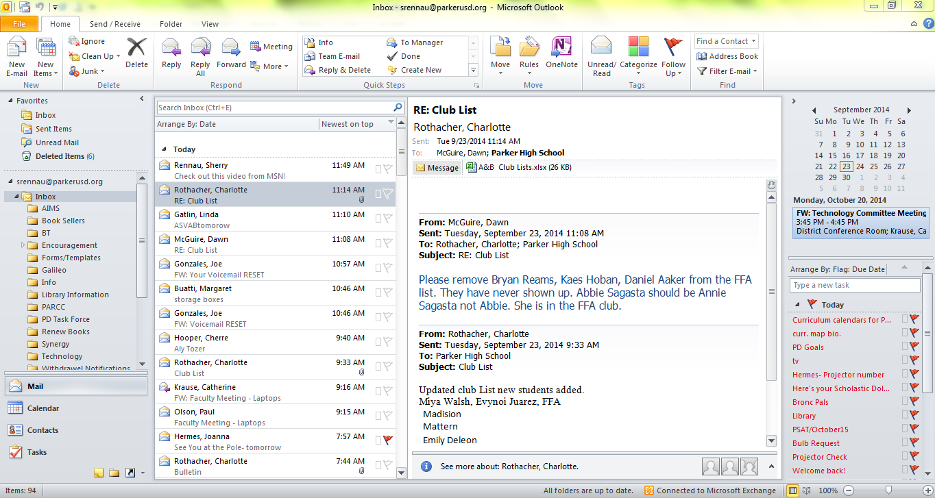
Reading Pane
People Pane
Ribbon

Instant Search

Navigation Pane

To Do Bar

Main View Buttons

Status Bar

Terms
Navigation Pane: used to switch information viewed
Ribbon: most frequently used Outlook Commands
To Do Bar: Keep track of upcoming appointments, meetings and tasks, flagged messages
Status Bar: used to switch between normal and reading views

Notes:
Main View Buttons
Status Bar
____________________________________________________________________________________________________________________________________________________________________________________________________________________________________________________________________________________________________________________________________________________________________________________________________________________________

